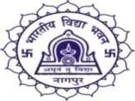 | BHAVAN’S BHAGWANDAS PUROHIT VIDYA MANDIR  TRIMURTI NAGAR, NAGPUR-440022.
GUIDE UNIFORM- GIRLS
(Std. VI to VIII)
BBPVM/TN/2025-26/Cir. No.6(a) ` 28th April 2026
Dear Parents,
The Guide uniform specification for Std. VI to VIII is as given below.

Complete Uniform for Girl Guide:- Salwar, Kameez and Dupatta
Salwar : - Deep Sky Blue Salwar.
Kameez :- Light Blue Kameez of plain non-transparent material. The length of the Kameez shall be up to the knees. The Kameez shall have two patch pockets, half sleeves 8 c.m. above the elbow turned up and stitched down cuffs 4 cm. wide open sports collar with epaulettes on both shoulders.
Dupatta :- Shall be deep Sky-Blue in colour made in plain non-transparent material.
[The Salwar and Kameez should not be tight-fitting.]

Belt :- Brown Nylon belt with the official Brass buckle of the Bharat Scouts and Guides
supplied by the National Association.
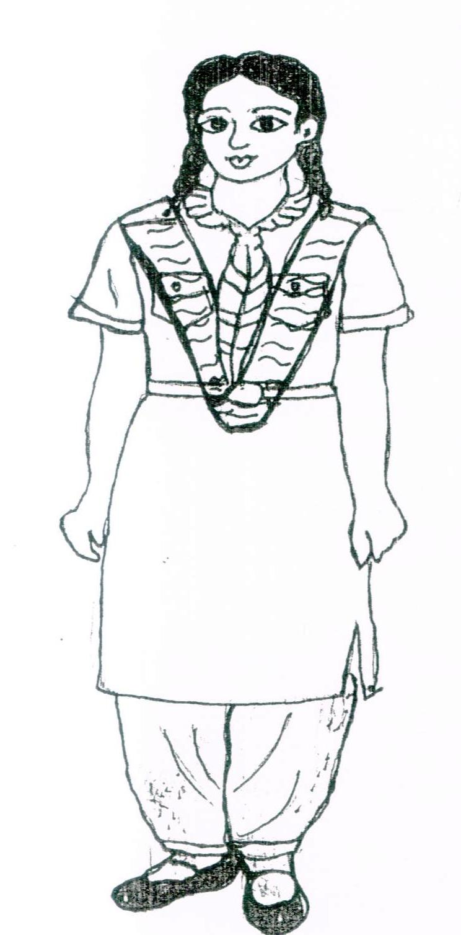 | Fabric :- Mafatlal (SEIKO) Shade No.: 464  For :- Kameez  Fabric :- Mafatlal (DILKHUSH) Shade No.46  For :- Salwar  Fabric :- GEORGET  For :- Dupatta

Head Dress :- Black Ribbon or Black Hair band
Footwear :- Black shoes (Action Genius Jogger – Article No. 67502) and Black socks
without design.
Note:-
1] The school does not authorize any shop for the sale of uniforms. Parents should purchase the uniform as per the prescribed colour and pattern. Parent should not buy scarf, Vogal, and batch with uniform.

(Smt. Parwati G. Iyer)
Principal
BHAVAN’S BHAGWANDAS PUROHIT VIDYA MANDIR,
TRIMURTI NAGAR, NAGPUR-440022.
SCOUT UNIFORM- BOYS
(Std. VI to VIII)
BBPVM/TN/2026-27/Cir. No.6(b) 28th April 2026
Dear Parents,
The Scout uniform specification for Std. VI to VIII is as given below.

Complete Uniform for Boy Scout:-
Shorts or Trousers: - Navy Blue shorts or trousers shall be worn.
Shirt :- A Steel Grey Shirt with two patch packets with shoulder straps.
Belt :- Brown Nylon belt with the official Brass buckle of the Bharat Scouts and Guides
supplied by the National Association.
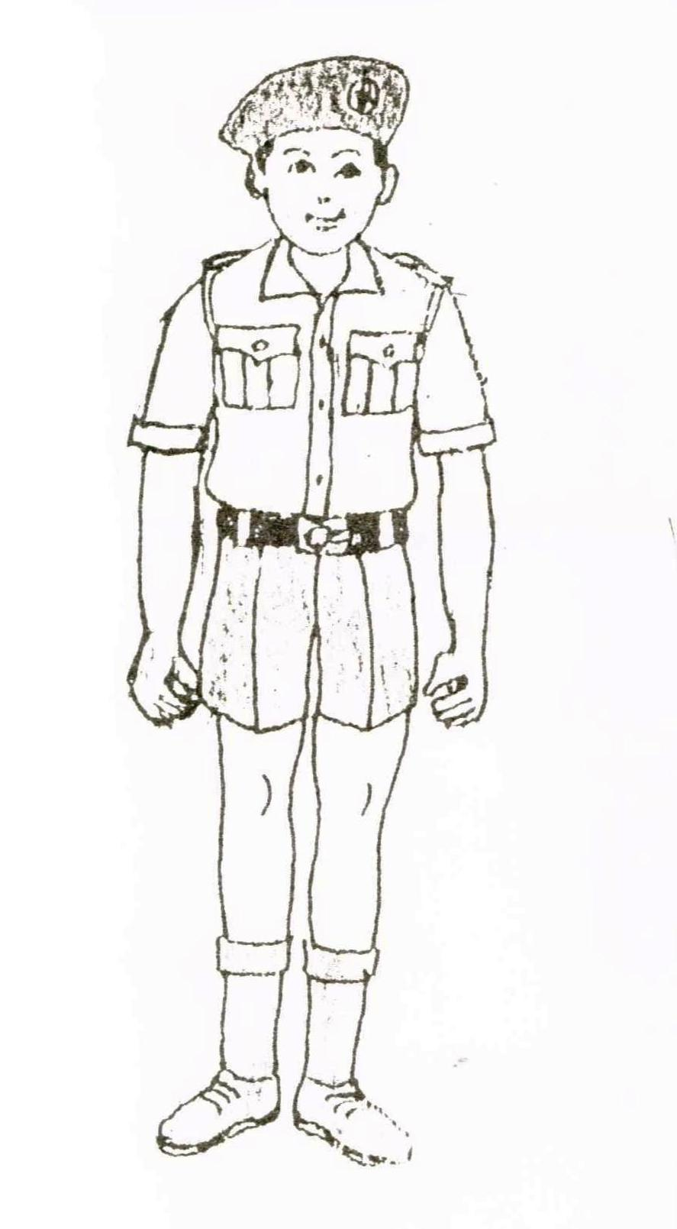 | Fabric :- S. Kumar’s Shade No.: 3378  For :- Shirt  Fabric :- S Kumar’s Shade No.: 3212  For :- Trouser

Head Dress : - Dark blue cap with the official cap badge. A Sikh may wear a dark blue turban with an official cap badge
Footwear :- Black shoes (Action Genius Jogger – Article No. 67502) and Black socks without design.

Note:-
1] The school does not authorize any shop for the sale of uniforms. Parents should purchase the uniform as per the prescribed colour and pattern. Parent should not buy scarf, Vogal, and batch with uniform.

(Smt. Parwati G. Iyer)
Principal

